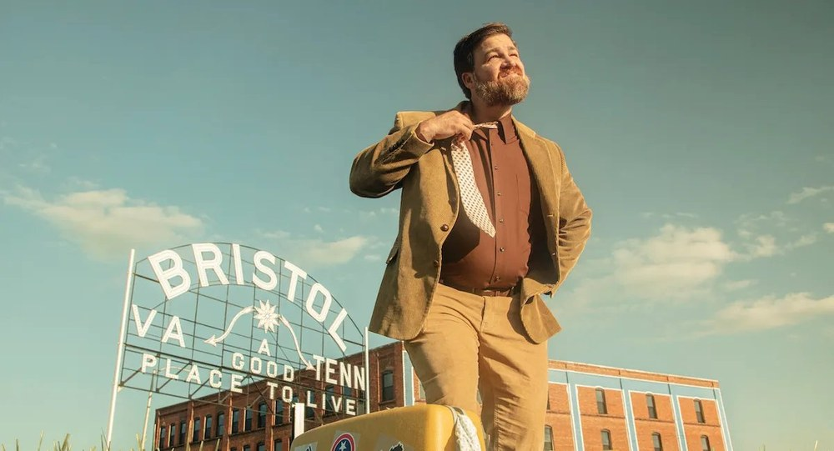
STAND-UP · PRESS KIT | PERFORMING SINCE 2002 · TWO #1 ALBUMS
A Boston Comedian in East Tennessee
Shawn
Carter
Twenty years of sharp, everyman comedy. Two #1 iTunes Comedy albums. One little club in Bristol.

BASED IN  Bristol, TN | OWNER  Blue Ridge Comedy | LATEST ALBUM  Boston to Bristol

✦ THE STORY
From Boston to Bristol.
“Shawn Carter relocates his comfort zone with new album Boston to Bristol.”
— VANYALAND
Shawn Carter is a stand-up comedian, writer, podcast host, and dad originally from Rockland, Massachusetts. He stepped on stage for the first time at The Comedy Connection in Faneuil Hall in October 2002 and spent over a decade as a mainstay in the Boston comedy scene.
In February 2020, Shawn and his wife Sarah left Boston on a road trip and ended up settling in Bristol, Tennessee. In 2021, they opened Blue Ridge Comedy Club in downtown Bristol, where Shawn serves as owner and showrunner.
His debut album 100 Problems, Vol. 1 hit #1 on the iTunes Comedy Chart and #7 on the Billboard Comedy Chart. His second album Boston to Bristol, released via Blonde Medicine in 2023, also debuted at #1 on iTunes Comedy.
Known for everyman sensibilities and sharp joke-writing, Shawn has opened for Pauly Shore, Deon Cole, Orny Adams, and Joe DeRosa, and has been delighting audiences in comedy clubs, Elks Lodges, and theatres for over 20 years.
  Boston to Bristol · 2023 |  | 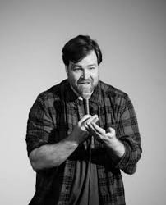  On stage · 20+ years |  | 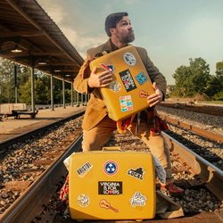  Bags packed, ready to roll

SHORT BIO · FOR POSTERS & BOOKINGS
Boston-born and Bristol-based, Shawn Carter is a stand-up comedian with two #1 iTunes Comedy albums and 20+ years on stage. He’s opened for Pauly Shore, Deon Cole, and Joe DeRosa, and owns Blue Ridge Comedy Club in downtown Bristol, TN.

✦ THE RECEIPTS
Credits & Press.
#1  ITUNES COMEDY  BOTH ALBUMS |  | #7  BILLBOARD  COMEDY CHART |  | 20+  YEARS  ON STAGE |  | 2021  FOUNDED  BLUE RIDGE COMEDY

◆ DISCOGRAPHY |  | ◆ OPENED FOR
  100 | 100 Problems, Vol. 1  2018 · #1 ITUNES · #7 BILLBOARD  Debut album. 15 tracks of sharp, everyman comedy.
  B2B | Boston to Bristol  2023 · BLONDE MEDICINE · #1 ITUNES  Recorded at The Rockwell, Somerville, MA. The move south, second marriage, adopting a kid, running a club.
  Pauly Shore | ★
  Deon Cole | ★
  Orny Adams | ★
  Joe DeRosa | ★

◆ PRESS
Vanyaland | “Shawn Carter relocates his comfort zone with new album Boston to Bristol.”
Boston Globe | Featured coverage
Billboard | #7 Comedy Chart — 100 Problems, Vol. 1
Boston Calling | 2020 Selected Performer

✦ WATCH
Video Reel.
▶ |  | Featured Set  youtube.com/watch?v=1Pff6rX54DY

▶ |  | Stand-Up Clip  youtube.com/watch?v=gBpm-d3MSLk
✦ GET IN TOUCH
Booking & Press.
BOOKING  shawncartercomedy@gmail.com  Direct booking inquiries · Press |  | WEB & CLUB  shawncartercomedy.com  Blue Ridge Comedy Club · Bristol, TN  blueridgecomedy.com

FOLLOW
INSTAGRAM  @shawn_carter_comedy | FACEBOOK  /ShawnCarterComedian | YOUTUBE  Shawn Carter
TWITTER / X  @shawncarters | SPOTIFY  Shawn Carter | APPLE MUSIC  Shawn Carter

Thanks for the look. ★ Let’s put on a show.

